Lunar Observing Program
Lunar Observing Program Coordinator:
Nina Chevalier
1662 Sand Branch Rd.
Bigfoot, Texas 78005
210-218-6288
ninalunar1@yahoo.com

Introduction  Welcome to the Astronomical League's Lunar Program. The Lunar Program introduces amateur astronomers to that object in the sky that most of us take for granted, and which deep sky observers have come to loathe. But even though deep sky observers search for dark skies (when the moon is down), this program gives them something to do when the moon is up. In other words, it gives us something to observe the rest of the month, and we all know that the sky is always clear when the moon is up.  The Lunar Program also allows amateurs in heavily light polluted areas to participate in an observing program of their own. This program is well suited for the young, inexperienced observer as well as the older observer just getting into our hobby since no special observing skills are required. It is well balanced because it develops naked eye, binocular, and telescopic observing skills. Finally, the Lunar Program was created as a project that can easily be done by schools and school children, especially those in the inner city.  Lunar Binocular Certification: There is a partial certification available for the Lunar Observing Program. For those completing the Naked-Eye and Binocular requirements a certificate is available. It is suitable to meet the requirements of the Binocular Master Observer Award. No telescope observations may be included in the Binocular Lunar Certification. | 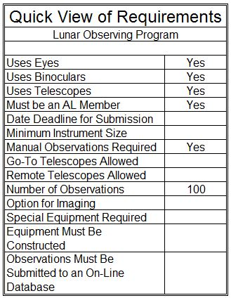

Rules and Regulations
To qualify for the AL's Lunar Observing Program certificate and pin, you need only be a member of the Astronomical League, either through an affiliated club or as a Member-at-Large, and observe 100 features on the moon. These 100 features are broken down into three groups: 18 naked eye, 46 binocular, and 36 telescopic features. Any pair of binoculars and any telescope may be used for this program. As a matter of fact, to prove that the Lunar Program could be done with small apertures, we used 7x35 binoculars and a 60mm refractor. So, as you can see, this program does not require expensive equipment. Also, if you have problems with observing the features at one level, you may go up to the next higher level. In other words, if you have trouble with any of the naked eye objects, you may jump up to binoculars. If you have trouble with any of the binocular objects, then you may move up to a telescope. But if you have trouble with any of the telescopic objects, you are on your own. You will have to arrange your own time on the Hubble Space Telescope. Before moving up to the next higher level, please try to get as many objects as you can with the instrument required at that level. Finally, when using binoculars, we recommend that you tripod mount them for stability.  We have made it as simple as possible to log your observations. Just list the instruments that you used where requested at the top of pages of the checklist, check off the features as you observe them in the "CHK" column, and then list the date, time, seeing, transparency, latitude, and longitude for when you observed the feature in the columns on the right-hand side of the checklist. That is all there is to it. | 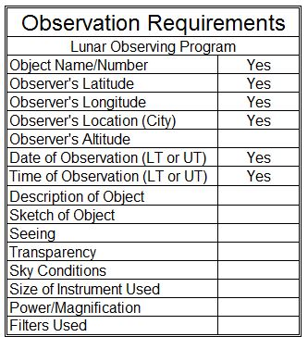
For those of you that still may have some trouble observing the 100 original features of the program, we have included 10 optional activities on the last page of the checkist. Each one optional activity counts as two of the standard observations , and may be substituted for those observations.
If you would like a good recommendation for a lunar map to use with this program, we suggest, for those of you on a budget, "Moon Map" (#5918X) by Sky Publishing Corp.. Sky Publishing Corp. can be reached at (888) 253-0230.
You must be a member of the Astronomical League to receive this certificate. If you are not a member now, click here to view information on membership in our organization.

Submitting for Certification
To receive your Lunar Program Certificate and award pin, simply send your observations along with your name, mailing address, email, phone number, club affiliation, and whom to send the certification; either to an officer of your astronomy club for review and approval, or to the Lunar Observing Program Coordinator.  If you are submitting for only the Binocular Certification, please be sure to indicate that on your submission.  Upon verification of your observations, your certificate and pin will be forwarded either to you or your club's Awards Coordinator, whomever you choose. You will also be added to the list of Lunar Program Awardees.  For information on which lunar features to observe, review the Lunar Observing Program (pfd file or Excel file). | 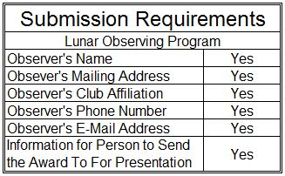

Note:
We would like to thank Steve Nathan for creating this Observing Program for the Astronomical League and for manning the helm from 1995 to 2017. He did an awesome job and we will miss his leadership. Thank you Steve.

Lunar Observing Program Coordinator:
Nina Chevalier
1662 Sand Branch Rd.
Bigfoot, Texas 78005
210-218-6288
ninalunar1@yahoo.com

