A.L.P.O. Mars Section Observation Log
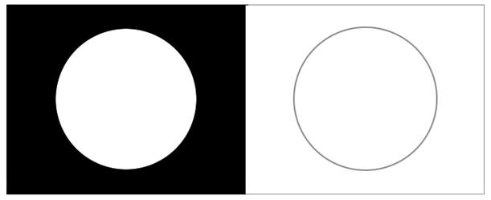
(Draw appearance in the left circle. Diagram the relative brighnesses in the right circle.)
Top drawing: Time (UT): __________________ Observer Name: _______________________________
Date (UT): _________________ CM: ___________°W Location: _____________________________________
Magnifications: _________ x, _________ x, _________x Telescope Aperture (cm): _____ Scope Type: ________
Filters: _________________________________________ E-Mail: _______________________________________
Seeing (0 to 10): _________ (V-I): __________
Transparency (1-6): __________ Comment on conditions: Blue (Violet) Clearing (0-3): __________
_______________________________________________ Dc: ________° Ds: ________° Ls: ________°
Bottom Drawing: Time (UT): __________________ Phase Angle or % Illum.: __________ circle: ° %
Date (UT): _________________ CM: ___________°W Apparent Diam. (arcsec.): __________
Magnifications: _________ x, _________ x, _________x
Filters: _________________________________________ Notes: ______________________________________
Seeing (0 to 10): _________ (V-I): __________ ____________________________________________
Transparency (1-6): __________ Comment on conditions: ____________________________________________
_______________________________________________ ____________________________________________
Notes: ___________________________________________________________________________________________
_________________________________________________________________________________________________
_________________________________________________________________________________________________
_________________________________________________________________________________________________
_________________________________________________________________________________________________

