Astronomical League
Earth Orbiting Satellite Observers Program
Observation Report Form

Observer’s Name: __________________________ Observation Number (1 – 28): ____________
Satellite Name and Element Set Satellite ID:
__________________________________________ Date of Observation: ___________________
Observation Site:
Latitude (°): _________________________ Longitude (°): ________________________
Elevation: __________ _____ feet _____ meters
Instrument: _____ Eyes Only, _____ Binoculars, _____ x _____,
_____ Telescope - Aperture: _______________ _____ mm _____ inches
Comments: _________________________________________________________________________
___________________________________________________________________________________
___________________________________________________________________________________
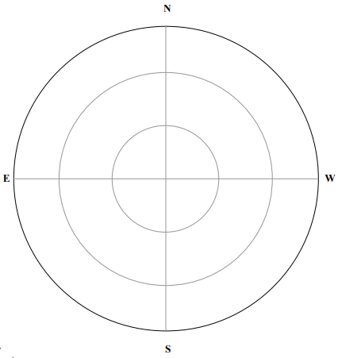

Draw or sketch the path of the satellite across the sky relative to bright stars. The outer ring on the sketch represents the horizon.
IMPORTANT: Place time “marks” on at least two locations on the satellite track, including the time zone and daylight/standard time references. For example: 01:20:50 UTC, 19:30:40 EST, 23:10:50 PDT, etc.

Observation Objective (check one task):
Active Payload: ___ 1, ___ 2, ___ 3, ___ 4
Manned Spaceflight: ___ 1, ___ 2, ___ 3
Rocket Bodies: ___ 1, ___ 2, ___ 3, ___ 4
Multi-pass: ___ 1a, ___ 1b, ___2a, ___ 2b
Aged Elsets: ___ 1a, ___ 1b, ___2a, ___ 2b
Multinational Satellites: ____ 1, ___2, ___ 3, ___ 4, ___ 5 ________________________ Country
Formation: ___ 1a, ___ 1b, ___2a, ___ 2b _____________________________ Spacecraft
Constellation: ___ 1a, ___ 1b ______________________ Constellation Name
Observing Guidelines and Suggestions
General Rules (subject to change)
- Provide one observation sheet for each observation task shown.
- Be sure to state both the spacecraft name and id (Satellite Number or International Designation) on each observation sheet.
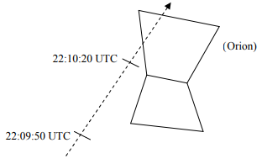
- Sketch the path of the satellite’s motion across the sky, being sure to include at least two time hacks and reference constellations, for example:
- Record the time of observations as accurately as possible. Use WWV or the U.S. Naval Observatory web site to set your clock before observing.
- Any single observation (pass) can only be used to satisfy one task, for example, observing the Space Shuttle flying in formation with the Space Station Alpha (ISS) can be used as an STS observation and an ISS observation, OR as a formation pass, but not both.
- If you have any questions, visit the EOSOP web site (http://www.rmss.org/eosoc/EOSOC_Intro.htm), submit them to the EOSOP listserv on the Internet (see the web site), or contact the EOSOP program administrator (eosoc@earthlink.net ).
- Verification of observations can be time consuming. After submitting copies of your observing logs, please be patient to allow time for the Coordinator to review your work and to send your EOSOP certificate. NOTE: Observing logs will NOT be returned - please submit copies only.
Active Payloads - These are satellites that are currently operational. Observe 4 different active payloads. These might include the Hubble Space Telescope, communications satellites, etc. (4 observations)
Manned Space Flight - These are spacecraft with people on board. Observe 3 different manned space flights. These could include the Internation Space Station, SpaceX missions, etc. (3 observations)
Multinational Satellites - These are satellites from different countries (not including the US). The distinction is the country that owns the satellite and is not based on where they were launched. (5 observations)
Rocket Bodies - These are parts of rockets that were used to get satellites into space. They may include R/B in their name. (4 observations)
Multi-Pass Satellites - These are two passes of a satellite that are viewed in the same evening or morning. Two different satellites should be observed. (4 observations)
Formation Flights - These are two spacecraft that are flying together. It may be a spacecraft approaching or leavig the Insternational Space Station, or two satellites that are flying together. (4 observations)
Aged Element Sets - Spacecraft orbits change from time to time to avoid debris or to return to their proper position. For most satellite observing it is important to have current Element Sets. For this set of observations, intentionally use old element sets. For each satellite, one observation must be with an element set less than one week old, and the second observation must be with an element set at least three weeks old. The intent is to experience the problems with old Element Sets. Accurate times are critical for this part. (4 observations)
Constellations - Constellations are goups of satellites working on the same mission. Observe two spacecraft in the same constellation. This might be Starlink, A-train, SPOT, etc. (2 observations)
Rev. 20250427

